

XJTLU Entrepreneur College (Taicang)
Module Code and Title | ENT208TC Industry Readiness
School Title | XJTLU Entrepreneur College (Taicang)
Assignment Title | Technical Documentation
Submission Deadline | Friday 15 May, 2026 before 23:59 (Beijing Time, GMT+8)
Session and Group | Session 1 — Group 16
Student IDs | 2360304  2363967  2361729  2363444  2363553  2361701  2359963
Final Word Count | 1873
If you agree to let the university use your work anonymously for teaching and learning purposes, please type “yes” here. | Yes

I certify that I have read and understood the University’s Policy for dealing with Plagiarism, Collusion, and the Fabrication of Data (available on Learning Mall Online). With reference to this policy, I certify that:
- My work does not contain any instances of plagiarism and/or collusion. My work does not contain any fabricated data.
By uploading my assignment onto Learning Mall Online, I formally declare that all of the above information is true to the best of my knowledge and belief.
Scoring — For Tutor Use
Student ID | D
Stage of Marking | Marker Code | Learning Outcomes Achieved (F/P/M/D) |  |  |  |  | Final Score
 |  | A | B | C | D | E
1st Marker — red pen
Moderation — green pen | IM Initials | The original mark has been accepted by the moderator: Y / N |  |  |  |  | Y / N
2nd Marker if needed



Section 1 — System Architecture

1.1 System Overview
The Connected Driver Safety Assistant is a low-cost embedded prototype designed to reduce risks related to drink-driving and fatigue driving. The system combines alcohol detection, fatigue monitoring, warning feedback, ignition-lock simulation, and APP-based interaction into one integrated workflow.

The prototype is built around the STM32F103C8T6 microcontroller. Sensor data from the MQ-3 alcohol sensor and E18 infrared sensor is processed locally to control OLED display output, buzzer and voice warnings, relay response, and wireless APP updates.

1.2 Component Overview
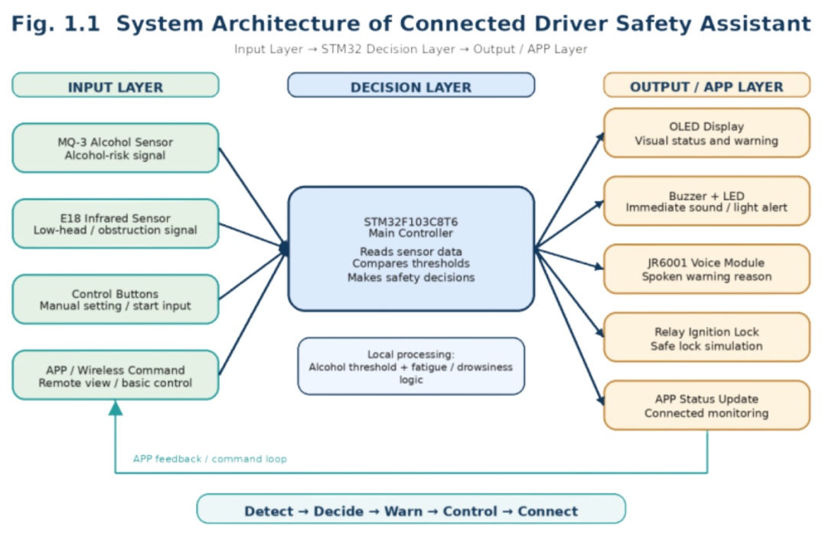
Fig. 1.1. Simplified architecture of the connected driver safety assistant. The STM32 controller connects sensor input, warning output, relay control and APP communication modules.
Component | Function | Why It Is Needed
STM32F103C8T6 | Central controller for sensor reading, threshold comparison and output control | Connects all modules into one complete workflow
MQ-3 Alcohol Sensor | Detects alcohol-related gas concentration before driving | Provides alcohol-risk input for safety decision-making
E18 Infrared Sensor | Detects low-head or obstruction behaviour | Provides simplified fatigue/drowsiness monitoring
OLED Display | Shows alcohol, fatigue, ignition and warning status | Gives real-time visual feedback to the driver
Buzzer + LED | Provides sound and visual alerts | Warns the driver immediately during risk conditions
JR6001 Voice Module | Plays spoken warning messages | Makes warnings easier to understand during driving
Relay Module | Simulates ignition lock/unlock control | Demonstrates active safety response
APP / Wireless Module | Provides connected monitoring and basic adjustment | Improves interaction and remote status viewing
The system combines these modules into one integrated workflow instead of using them as separate hardware functions. User feedback was also used to improve warning clarity, OLED readability and APP interaction.

1.3 Data Flow
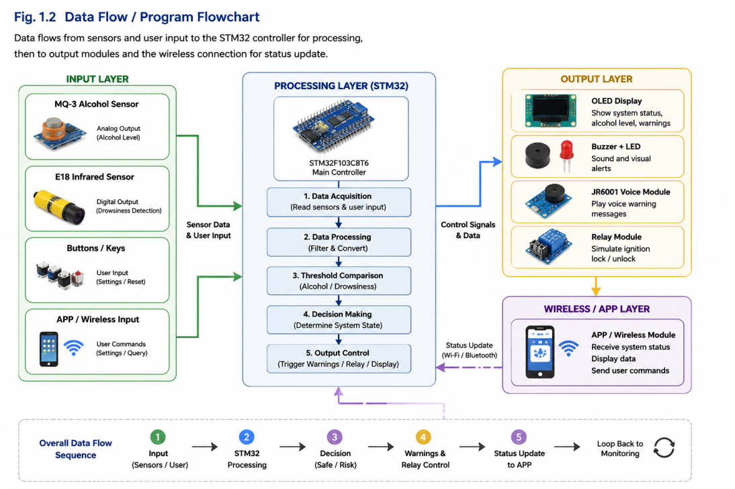
Fig. 1.2. Data flow of the prototype from sensor input to warning output, relay response and APP status update.
The system begins by collecting alcohol and fatigue-related input from the MQ-3 and E18 sensors. The STM32 controller processes the sensor values and compares them with predefined thresholds.

If a risk condition is detected, the system activates warning outputs including OLED messages, buzzer alerts, JR6001 voice reminders, and relay ignition-lock simulation. The current system status is also transmitted to the APP module for wireless monitoring and adjustment.

1.4 Physical Prototype and Enclosure Design
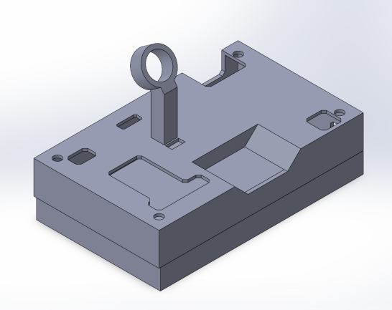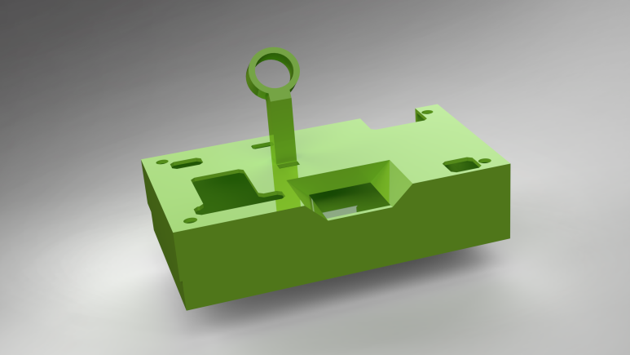
Fig. 1.3. CAD model of the custom 3D-printed enclosure designed for the prototype. The enclosure improves hardware organisation and product-level presentation.
A custom enclosure was designed and fabricated using 3D printing to improve prototype organisation and usability. Compared with a loose wiring prototype, the enclosure makes the system easier to handle, safer to demonstrate, and closer to a product-oriented implementation.
The enclosure also improves cable management and module placement, while providing a more realistic in-vehicle presentation for Demo Day evaluation.

Section 2 — Technology Justification
The project combines low-cost embedded hardware, multi-modal warning output, and wireless interaction to improve driving safety for elderly drivers and ordinary family vehicles. Technology choices were influenced not only by functionality, but also by usability, readability, installation practicality, and user feedback collected during validation sessions.

2.1 Core Technology Selection
Technology / Tool | What we chose | Alternatives considered | Why we chose this
Main controller | STM32F103C8T6 | Arduino Uno, ESP32 | Stable embedded control and reliable multi-module integration
Alcohol detection | MQ-3 sensor | MQ-2 sensor, camera analysis | Low-cost sensor designed for alcohol-related gas detection
Fatigue detection | E18 infrared sensor | Camera vision, eye-tracking | Simpler implementation with lower privacy concerns
Warning output | OLED + buzzer + JR6001 | Buzzer-only warning | Multi-modal warning improves clarity during driving
User interaction | APP / wireless adjustment | Physical buttons only | Easier calibration and personalised settings

Technical Risks and Mitigation
Early testing showed that buzzer-only warnings were difficult to distinguish during driving. The final system therefore adopted multi-modal warning output combining OLED prompts, buzzer alerts, and voice reminders. Another challenge involved false alarms caused by fixed infrared sensing distance. APP-based sensitivity adjustment was introduced to improve reliability for drivers with different seating positions. The hardware was also redesigned into a compact PCB and enclosure after users reported dashboard obstruction problems.

2.2 User-Driven Design Changes
User validation significantly influenced the final hardware and interaction design. Early versions relied mainly on buzzer alerts and a small OLED display, but users reported poor warning clarity during driving. The final prototype introduced a multi-modal warning structure combining OLED prompts, buzzer alerts, and JR6001 voice reminders.
Validation also revealed readability and installation issues. The interface was redesigned with larger Chinese text and softer LED lighting, while the hardware was miniaturised into a compact PCB and custom enclosure.
Figure 2.1 shows the transition from the original breadboard prototype to the compact PCB and enclosure design. Figure 2.2 summarises the main user-driven improvements introduced during validation.
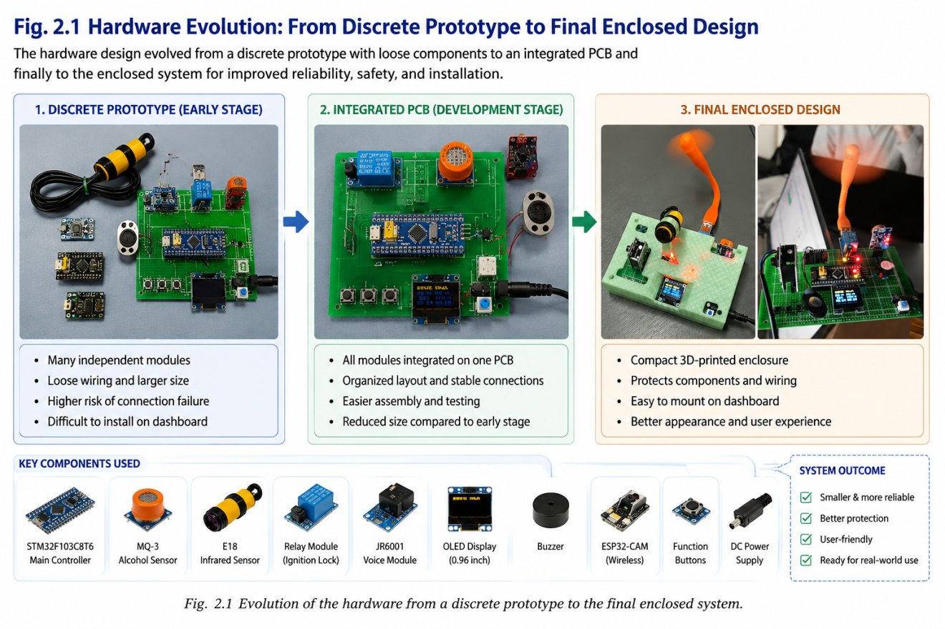
Fig. 2.1. Evolution of the hardware structure from an early breadboard prototype to a compact PCB and custom enclosure design.
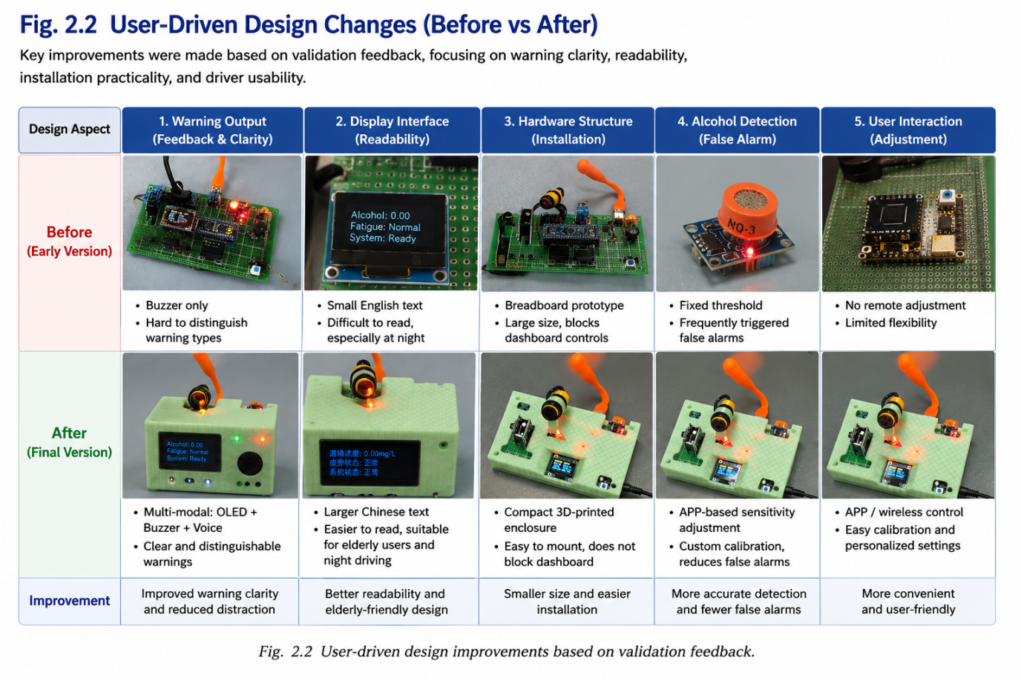Fig. 2.2. User-driven design improvements including larger OLED text, multi-modal warning output, enclosure optimisation, and APP-based calibration.

Section 3 — Deployment Guide

3.1 Environment Requirements
Requirement | Version / Notes
Operating System | Windows 10 / Windows 11
Development Platform | STM32CubeIDE
Microcontroller | STM32F103C8T6
Programming Language | Embedded C
Power Supply | 5V DC adapter or USB power
Communication Modules | Bluetooth / ESP8266 Wi-Fi module
Sensors | MQ-3 alcohol sensor, E18 infrared sensor
Output Devices | OLED display, buzzer, LED, JR6001 voice module
Additional Hardware | Relay module, custom PCB, 3D-printed enclosure
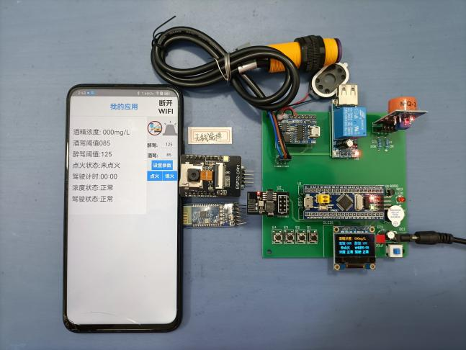
Fig. 3.1. Final hardware assembly including STM32 controller, sensors, OLED display, relay module, and warning devices.

3.2 Setup Steps
Connect all sensors and output modules to the STM32 controller according to the PCB layout design. Ensure that the MQ-3 alcohol sensor, E18 infrared sensor, OLED display, buzzer, relay module, and voice module are correctly connected to the designated GPIO pins.
• Connect all sensors and output modules to the STM32 controller according to the PCB layout.
• Upload the embedded program using STM32CubeIDE through USB connection.
• Power the prototype using USB or a 5V DC supply.
• Verify that the OLED display, buzzer, voice module, relay module, and APP communication operate correctly.
Verification checklist:
Function | Expected Result
Alcohol detection | OLED and voice warning activated
Fatigue detection | Infrared sensor triggers warning
Relay module | Ignition-lock simulation activates
APP connection | Wireless monitoring functions normally
OLED display | Warning information displayed clearly

3.3 Common Issues and Solutions
Problem | Likely Cause | Solution
OLED display not working | Incorrect wiring or unstable power supply | Reconnect OLED pins and check 5V output
False fatigue alarms | Sensor distance not calibrated | Adjust sensitivity using APP settings
No voice warning output | JR6001 module not connected correctly | Check TX/RX wiring and module power
Wireless APP cannot connect | Bluetooth or Wi-Fi module disabled | Restart communication module and reconnect
Relay module not responding | Incorrect GPIO configuration | Verify STM32 output pin settings in firmware

3.4 Deployment Notes
The prototype is designed for demonstration and validation purposes rather than direct automotive deployment. The relay module simulates ignition-lock behaviour without directly controlling a real vehicle ignition system. This approach improves development safety while still demonstrating the intended warning workflow and user interaction process.

Section 4 — IP Strategy
The Connected Driver Safety Assistant combines alcohol detection, fatigue monitoring, multi-modal warning output, and APP-based interaction into a compact embedded safety prototype. While similar technologies already exist separately in commercial driver monitoring systems, the novelty of this project lies in integrating low-cost embedded sensing, elderly-friendly warning interaction, and wireless calibration into a single compact prototype designed for accessibility and usability.

4.1 Novelty Analysis
Most existing driver safety systems focus on either alcohol detection or fatigue monitoring separately. In contrast, this project combines alcohol detection, fatigue warning, multi-modal alerts, and APP-based calibration into one low-cost embedded prototype.
The project also focuses strongly on usability for elderly drivers through larger OLED text, simplified interaction, and voice-based warning feedback.

4.2 Prior Art
Existing product / patent | What it does | How your solution differs
Driver Alcohol Detection System for Safety (DADSS) | Alcohol detection before driving | Adds fatigue monitoring and multi-modal warning
Tesla Driver Monitoring System | Camera-based fatigue monitoring | Uses low-cost infrared sensing and local processing
Smart Breathalyzer | Detects alcohol level | Adds relay simulation and APP interaction

4.3 Patent Decision
The team does not currently plan to apply for a patent. Although the prototype combines several existing technologies into one integrated system, the core sensing technologies themselves are not entirely novel. At this stage, the project focuses more on iterative improvement, usability testing, and prototype development.

4.4 Alternative Protection
Instead of patent protection, the project relies more on iterative design improvement and user-centred optimisation. Continued validation testing and hardware refinement may help strengthen the product concept before future commercialisation.

Section 5 — Limitations & Future Work
The current prototype successfully demonstrates alcohol detection, fatigue monitoring, multi-modal warning interaction, and APP-based calibration. However, several technical and practical limitations still exist at the current development stage.

5.1 Known Limitations
Limitation | Why it exists | Impact on users
Infrared fatigue detection may trigger false alarms | Different drivers have different seating positions and heights | Some users may receive incorrect fatigue warnings
Relay module only simulates ignition lock | Real vehicle ignition integration requires automotive-grade safety design | The prototype cannot directly control a real vehicle
APP functions are still basic | Limited development time and hardware resources | Wireless interaction and data visualisation remain limited
Prototype depends on external power supply | Current system is designed mainly for testing and validation | Portability and long-term deployment are limited

5.2 Future Work
• Improve fatigue detection accuracy using camera-based monitoring.
• Enhance APP connectivity and real-time data visualisation.
• Optimise enclosure portability and long-term deployment stability.

References
- DADSS Program, “Driver Alcohol Detection System for Safety (DADSS),” Traffic Injury Research Foundation, 2024.
- Tesla, “Driver Monitoring System,” Tesla Vehicle Safety Documentation, 2024.
- STMicroelectronics, “STM32F103x8/xB Datasheet,” STMicroelectronics, 2023.
- Hanwei Electronics, “MQ-3 Alcohol Gas Sensor Manual,” Zhengzhou Winsen Electronics Technology Co., Ltd., 2023.
- ESPRESSIF Systems, “ESP8266 Wi-Fi Module Documentation,” Espressif Systems, 2023.
- Waveshare, “0.96-inch OLED Display Module User Manual,” Waveshare Electronics, 2023.
- EBYTE, “E18-D80NK Infrared Sensor User Guide,” EBYTE Electronics, 2023.
- Arduino, “Relay Module Basics and Safety Applications,” Arduino Documentation, 2022.
- Norman, D., The Design of Everyday Things, Revised and Expanded Edition, Basic Books, 2013.
- Krug, S., Don’t Make Me Think: A Common Sense Approach to Web Usability, 3rd ed., New Riders, 2014.

